Lab Task 6
Areesha Raheel
55039
BSIT-6

Job Scheduling Algorithm
Time Complexity
- Sorting: O(n log n)
- Slot checking: O(n²)
- Overall: O(n²)
Real-Life Applications
- CPU Task Scheduling
- Printer Job Scheduling
- Project Management
- Cloud Resource Allocation
- Manufacturing Systems

1. Write a program that takes a list of jobs (each with an ID, deadline, and profit), and prints them sorted in decreasing order of profit.
#include <iostream>
#include <algorithm>
using namespace std;

struct Job {
char id;
int deadline;
int profit;
};
bool compare(Job a, Job b) {
return a.profit > b.profit;
}

int main() {
Job jobs[] = {
{'A', 2, 20},
{'B', 2, 60},
{'C', 1, 40},
{'D', 3, 100},
{'E', 4, 80}
};

int n = 5;

sort(jobs, jobs + n, compare);

cout << "Jobs sorted by decreasing profit:\n";

for (int i = 0; i < n; i++) {
cout << jobs[i].id
<< " Deadline: " << jobs[i].deadline
<< " Profit: " << jobs[i].profit << endl;
}
return 0;
}
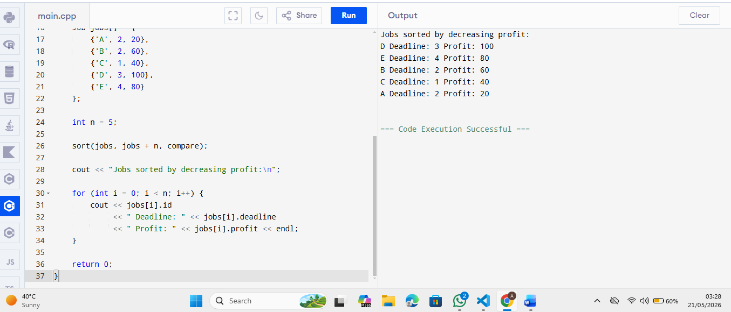

2. After performing job scheduling, check whether a specific job (e.g., Job 'B') was selected in the final job sequence or rejected.
CODE:
#include <iostream>
#include <algorithm>
using namespace std;

struct Job {
char id;
int deadline;
int profit;
};

bool compare(Job a, Job b) {
return a.profit > b.profit;
}

int main() {

Job jobs[] = {
{'A', 2, 20},
{'B', 2, 60},
{'C', 1, 40},
{'D', 3, 100},
{'E', 4, 80}
};

int n = 5;

sort(jobs, jobs + n, compare);

int maxDeadline = 4;

bool slot[4] = {false};
char result[4];

for (int i = 0; i < n; i++) {

for (int j = min(maxDeadline, jobs[i].deadline) - 1; j >= 0; j--) {

if (!slot[j]) {
slot[j] = true;
result[j] = jobs[i].id;
break;
}
}
}

char searchJob = 'B';
bool found = false;

for (int i = 0; i < maxDeadline; i++) {
if (slot[i] && result[i] == searchJob) {
found = true;
}
}

if (found)
cout << "Job " << searchJob << " was SELECTED.\n";
else
cout << "Job " << searchJob << " was REJECTED.\n";

return 0;
}
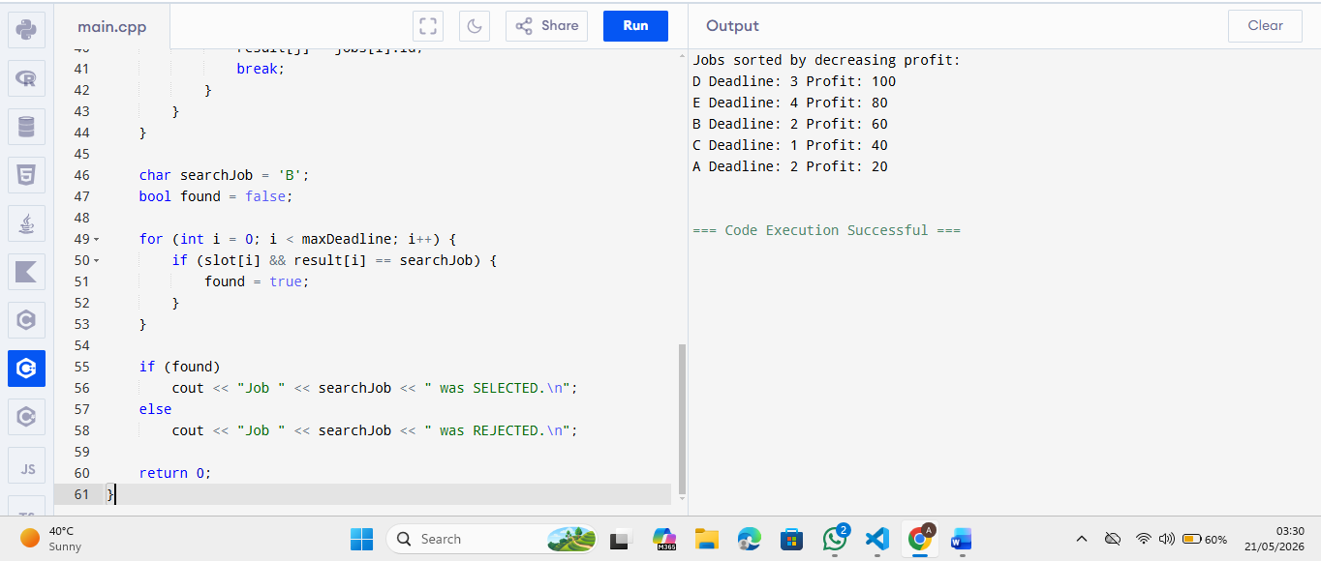

3. Write a program that not only schedules jobs for maximum profit but also lists which jobs were rejected due to deadline unavailability.
Code:
#include <iostream>
#include <algorithm>
using namespace std;

struct Job {
char id;
int deadline;
int profit;
};

bool compare(Job a, Job b) {
return a.profit > b.profit;
}

int main() {

Job jobs[] = {
{'A', 2, 20},
{'B', 2, 60},
{'C', 1, 40},
{'D', 3, 100},
{'E', 4, 80}
};

int n = 5;

sort(jobs, jobs + n, compare);

int maxDeadline = 4;

bool slot[4] = {false};
char result[4];

char rejected[10];
int rejectCount = 0;

int totalProfit = 0;

for (int i = 0; i < n; i++) {

bool scheduled = false;

for (int j = min(maxDeadline, jobs[i].deadline) - 1; j >= 0; j--) {

if (!slot[j]) {
slot[j] = true;
result[j] = jobs[i].id;
totalProfit += jobs[i].profit;
scheduled = true;
break;
}
}

if (!scheduled) {
rejected[rejectCount++] = jobs[i].id;
}
}

cout << "Scheduled Jobs:\n";

for (int i = 0; i < maxDeadline; i++) {
if (slot[i]) {
cout << "Slot " << i + 1 << " -> Job " << result[i] << endl;
}
}

cout << "\nRejected Jobs:\n";

for (int i = 0; i < rejectCount; i++) {
cout << rejected[i] << endl;
}

cout << "\nTotal Profit = " << totalProfit << endl;

return 0;
}

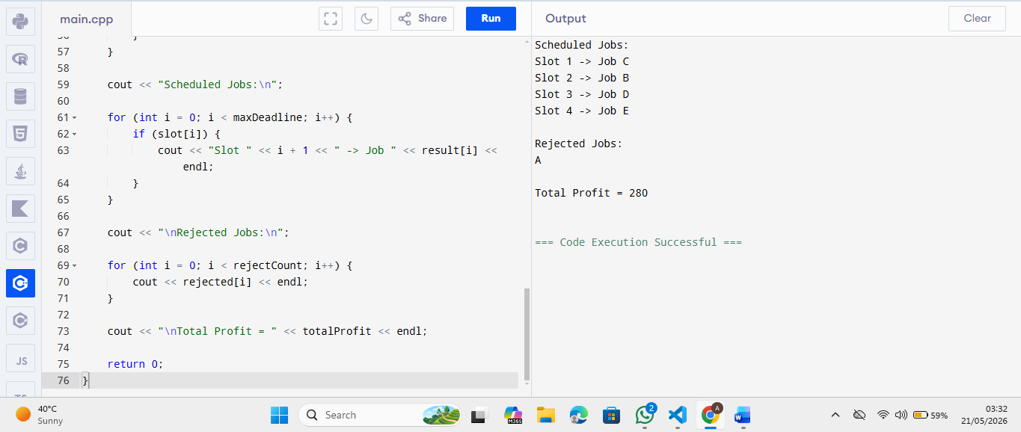
4. Write a function that returns the count of scheduled jobs and the total profit earned after scheduling with deadlines.

#include <iostream>
#include <algorithm>
using namespace std;

struct Job {
char id;
int deadline;
int profit;
};

bool compare(Job a, Job b) {
return a.profit > b.profit;
}

void jobScheduling(Job jobs[], int n) {

sort(jobs, jobs + n, compare);

int maxDeadline = 0;

for (int i = 0; i < n; i++) {
if (jobs[i].deadline > maxDeadline)
maxDeadline = jobs[i].deadline;
}

bool slot[10] = {false};

int countJobs = 0;
int totalProfit = 0;

for (int i = 0; i < n; i++) {

for (int j = min(maxDeadline, jobs[i].deadline) - 1; j >= 0; j--) {

if (!slot[j]) {
slot[j] = true;
countJobs++;
totalProfit += jobs[i].profit;
break;
}
}
}

cout << "Total Scheduled Jobs = " << countJobs << endl;
cout << "Total Profit = " << totalProfit << endl;
}

int main() {

Job jobs[] = {
{'A', 2, 20},
{'B', 2, 60},
{'C', 1, 40},
{'D', 3, 100},
{'E', 4, 80}
};

int n = 5;

jobScheduling(jobs, n);

return 0;
}
